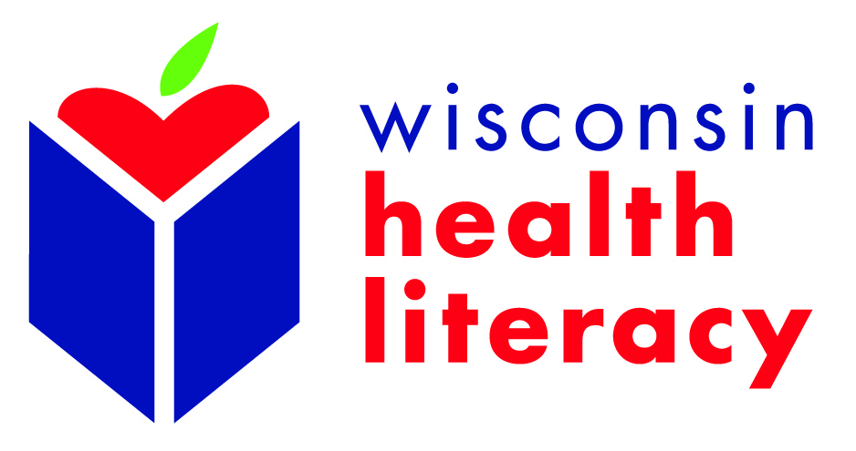

2017 Wisconsin Health Literacy Summit
Call for Poster Presenters - Deadline Extended

The 2017 Wisconsin Health Literacy Summit: “Health Literacy: A Critical Link in Patient Engagement,” will be held April 4-5, 2017, in Madison, Wisconsin. We have extended the deadline to March 1, 2017 for individuals to submit proposals for the poster presentation.

Priority will be given to proposals which demonstrate how improved health communication and/or increased patient engagement can lead to better outcomes, including:

- How health literate communications can help people become more engaged with their health and healthcare
- Reducing health literacy barriers for those with chronic disease
- Integrating health literacy into health prevention or oral health initiatives
- Assisting consumers in accessing, understanding and using health insurance
- Integrating health literacy practices and/or programs into adult literacy curricula
- Cultural competency and including populations served in designing, implementing and evaluating health information
- Measuring and evaluating the impact of health literacy interventions
- Building support for and/or implementing health literacy initiatives in a health care or health insurance organization

Other relevant and timely topics will also be considered.
To apply to present a poster, complete and submit the following application as a Word document by March 1, 2017 to: kari@wisconsinliteracy.org. Poster presenters will be notified of their selection by March 7, 2017. Poster presenters must register for the Summit and may take advantage of the reduced presenter rate of $150.

For any questions, please contact:
Kari LaScala
Health Communications Specialist
kari@wisconsinliteracy.org

Summit Poster Presentation Proposal
(Note: Boxes will expand as you enter content)

Poster Presentation Title:

Lead Presenter Description:
(Name, title, organization, maximum 100-word biography, education, including institution, major area of study, degree, year awarded.

Lead Presenter Contact information:
(Include mailing address, email, work phone, mobile phone)

Co-presenter (if any) Description:
(Name, title, organization, maximum 100-word biography, education, including institution, major area of study, degree, year awarded.

Co-presenters (if any) Contact information:
(Include name, title, organization, email address, phone for each)

Abstract/Proposal Description:
(300 word limit)

Brief Summary Description for Conference Website and Program
(100-word limit – content may be edited as needed)
- Example:
  - Nearly 60% of adults 65 and older are estimated to be in the lowest two levels of health literacy. Yet they also are most at risk, given increased health issues, higher medication use, and more health care visits. This session will help participants recognize low health literacy and learn easy-to-use techniques to help seniors stay healthy and fully benefit from health care services. Information from an ongoing statewide medication use education project will be shared. It will illustrate ways lower health literacy can affect seniors’ use of medicines, what can be done to improve it, and how collaborating partners, such as a health insurance company, can help disseminate the message.

Intended Primary Audience (select only one):
☐ Health care providers (physicians, nurses, and other clinical staff)
☐ Health system administrators
☐ Health insurers
☐ Health educators or communicators
☐ Pharmacists
☐ Adult literacy providers
☐ Public health professionals & policymakers
☐ Academic researchers
☐ Other (please specify)_____________________________

Intended Secondary Audience (select only one):
☐ Health care providers (physicians, nurses, and other clinical staff)
☐ Health system administrators
☐ Health insurers
☐ Health educators or communicators
☐ Pharmacists
☐ Adult literacy providers
☐ Public health professionals and/or policymakers
☐ Academic researchers
☐ Other (please specify)_________________
☐ This presentation does not apply to any secondary audiences

Teaching Methods Used (Workshops only--check all that apply)
☐Lecture
☐Skill building exercise
☐Small or large group discussion
☐Other (please specify)____________________________

Three Learning objectives (complete below):

Learning Objective 1:
Participant will be able to…
Learning Objective 2:
Participant will be able to…

Learning Objective 3:
Participant will be able to…

Presenter Release:
Presenter agrees that Wisconsin Health Literacy and its agents may:
- Use, for advertising, the presenter’s name, photo (if applicable), presentation title, presentation description and/or biographical data on connection with the presentation.
- Include speaker’s presentation in conference material distribution to all participants; however, presenter reserves the right to withhold handouts which he/she does not want distributed.
- Post video recording of presentation for educational and promotional purposes.
- Post copies of handouts on the website.

Signed: ____________________________________________________________

Person Completing Form (if completed by someone other than Lead Presenter)
(Provide name and contact information.)

