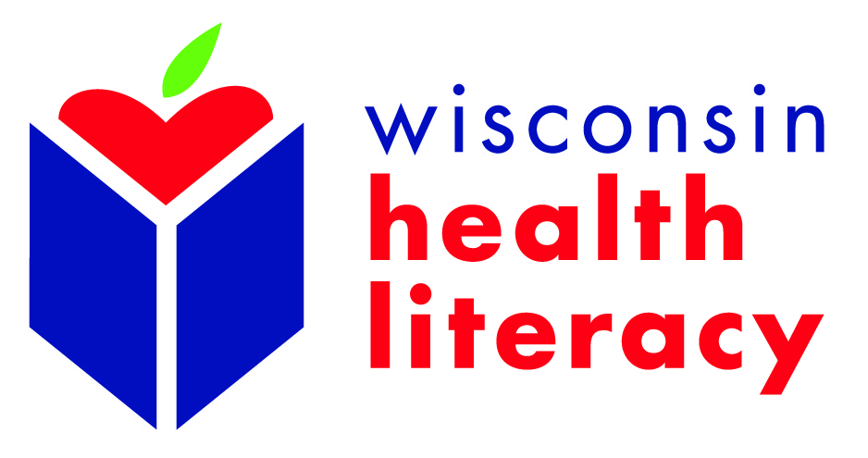

2019 Wisconsin Health Literacy Summit Scholarship Application:
A limited number of scholarships are available to provide support for qualifying professionals to attend the 2019 Wisconsin Health Literacy Summit: “A sharper view through the lens of health literacy” on April 2-3, 2019 in Madison, Wisconsin. Please note that the scholarship does not cover the Pre-Summit Workshops on April 1, 2019. Recipients are encouraged to attend this day, but at the additional fee.

View the scholarship options below and apply by January 31, 2019. Applicants will be notified of their acceptance by February 11, 2019.

*The number of scholarships awarded is dependent on a pending grant application for conference support.

- Literacy Scholarship – This scholarship will provide support for both in-state members of Wisconsin Literacy, Inc. and out-of-state literacy coalition leaders. Recipients must be program managers or directors or in a position to implement health literacy initiatives at the agency.

This scholarship includes:
  - Registration fee ($325 value)
  - One or two nights’ hotel stay ($149 per night value)

Note: All Wisconsin Literacy, Inc. member agencies will automatically qualify for a reduced registration fee of $150 regardless of their scholarship status.
- High Impact, Limited Resources (HILR) Scholarship - This scholarship is available to those who work directly with at-risk populations, but may not have the financial resources to attend the Summit without some assistance. Examples include professionals who work in federally qualified health centers, parish nurses, public health departments, or community-based health care agencies.
This scholarship includes:
  - Reduced registration fee of $110 ($215 value)
  - One or two nights’ hotel stay ($149 per night value)

Continued
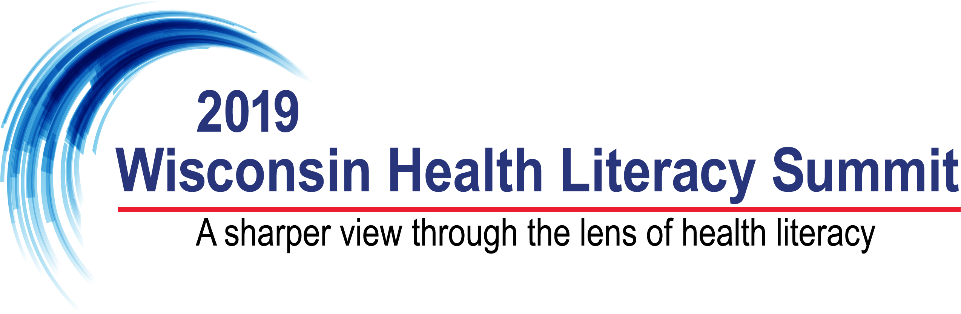

Scholarship Application (complete the following):

Name:
Title and/or Position Description:
Organization:
Address:
Phone/Email:

For which type of scholarship are you applying? (select one)
- Literacy
- High Impact, Limited Resources (HILR)

For HILR:
I would be unable to attend this conference without this scholarship.
- Yes
- No
For All:
Please explain why you want to attend the 2019 Wisconsin Health Literacy Summit (200 words or less):

Please tell us about the population(s) you serve or work with (demographics & geographic area) AND: How attending the Summit will help you in advancing your work (200 words or less)

Please send application to:
Caitlyn Mowatt
Health Communications Specialist
Wisconsin Literacy, Inc.
211 S. Paterson St., Ste 260
Madison, WI 53703
or via e-mail to: caitlyn@wisconsinliteracy.org

